## 

## 

## **CHECKPOINT 4**

## **EXE101 - Experiential Entrepreneurship**

## 

## 

**LECTURE :** Le Thi Dieu Thoa

**CLASS :** SE17C.NET

**SEMESTER :** Fall 2024

**GROUP :** DAWN

**MEMBER**

Le Nguyen Phuc Anh QE170043

Nguyen Tran Huu Phuc QE170051

Nguyen Hoang Vu QE170032

Nguyen Thi Thuy QE170033

By Phi Hung QS170163

Tran Phan Nhat QS170165

**CHECKPOINT 4**  **1**

**EXE101 - Experiential Entrepreneurship**  **1**

**I. Team Profile**  **5**

1. Introduction  5

a. Company name  5

b. Logo  5

c. Slogan  5

d. Meaning  5

e. Mission of the company  5

2. Company Structure  6

3. Member Roles  6

4. Product Descriptions  6

**II. PRODUCT MARKET FIT**  **7**

1. MARKET SIZE  7

1.1 Customer segmentation  7

1.2. Market potential  8

2. SURVEY  9

3. MARKET MIX  9

a. Product  9

b. Price  10

c. Place  10

d. Promotion  10

4. COMPETITOR  11

**III. Business Model Canvas and Technology Tool**  **12**

1. Business Model Canvas  12

a. Key partners  12

b. Key activities  12

c. Value Proposition  13

d. Customer Relationship  14

e. Customer Segments  14

f. Key resources  15

g. Channels  15

h. Cost structure  16

i. Revenue stream  17

2. Technology Tool  17

**IV. Operation**  **18**

1. Supplier Relationship Management  18

1.1. Identify and select suppliers  18

1.2. Supplier reviews  18

1.3 Negotiate  18

2. Customer Relationship Management  19

2.1. Manage all customer data  19

2.2. Building a customer care program  19

2.3. Feedback analysis and service optimization  19

2.4. Personalize the customer experience  20

2.5. Evaluation of performance indicators  20

3. Employee Relationship Management  20

3.1. Compensation and benefits policy  20

3.2. Training and development  20

3.3. Reward and recognition policy  20

3.4. Employee retention policy  21

3.5. Performance evaluation  21

4. Inventory management  21

**V. Financial Analysis (projection for 5 years)**  **21**

1. Initial costs: (Year 0)  21

2. Revenue stream: (Year 1,2,3,4,5)  22

3. Operating expenses: (Year 1,2,3,4,5)  23

a. Fixed costs:  23

b. Variable costs:  23

c. Total cost:  23

4. Expected Profits:  24

## 

## 

## 

## **I. Team Profile**

### **1. Introduction**

#### **a. Company name**

DawnFood

#### **b. Logo**

#### 

#### **c. Slogan**

"Your Daily Meal, Delivered with Care"

#### **d. Meaning**

"DawnFood" symbolizes starting the day with a nutritious meal, supporting the health and modern lifestyle of customers. We bring energy to the new day through breakfast prepared and delivered to your doorstep.

#### **e. Mission of the company**

DawnFood is committed to providing delicious, nutritious and convenient breakfast meals, ensuring food quality and safety, while bringing absolute convenience to customers.

### **2. Company Structure**

* CEO (Chief Executive Officer): Managing the company's strategy and comprehensive management, ensuring the sustainable development of the business.
* COO (Chief Operations Officer): Mainly responsible for operational activities, participating in developing operational strategies, and monitoring and controlling company costs.
* CSMO (Chief Sales & Marketing Officer): Developing the company's sales and marketing strategy, in charge of building and managing brand image, and managing sales and distribution channels.
* CTO (Chief Technology Officer): Develop and drive technology strategy, responsible for evaluating and applying new technologies to improve the company's products and operating processes.
* CRDO (Chief Research and Development Officer): Responsible for building and promoting research and development strategies, applying new technologies and scientific discoveries to develop new products.

### **3. Member Roles**

Le Nguyen Phuc Anh: CEO (Chief Executive Officer)

Nguyen Tran Huu Phuc: COO (Chief Operations Officer)

Nguyen Hoang Vu: CSMO (Chief Sales & Marketing Officer)

Do Phi Hung: CTO (Chief Technology Officer)

Tran Phan Nhat: CRDO (Chief Research and Development Officer)

### **4. Product Descriptions**

* **DawnFood Service:** The service provides a variety of breakfast meals, including Pho, Bun, Xoi, Mi Quang,... and vegetarian dishes. Customers can create their own menu and pre-order meals for many days
* **Customized Meal Plans:** Customers can create their own menus and schedule meal delivery for the entire week, with a wide range of food and portion options to suit their individual needs.
* **Mobile and Web App:** Mobile app and website make it easy for customers to order meals, track orders, and receive daily food recommendations

## **II. PRODUCT MARKET FIT**

### **1. MARKET SIZE**

#### **1.1 Customer segmentation**

Customer segment analysis for the DAWNFOOD startup idea in Binh Dinh province with a population of **1,487,900** people (binhdinh.gov.vn) will be analyzed according to the following aspects and will also rely on these aspects for the team to develop the menu:

**1.1.1. Age** :

* **Students** (16 - 22 years old): interested in fast, convenient and affordable breakfast.
* **Working people** (23-45 years old): busy in the morning, so prefer fast, convenient meals and are willing to pay more to save time but still ensure energy for work.
* **Elderly people** (over 45 years old): If you care about your health, you can choose light, low-fat breakfasts.

**1.1.2.** **Income** :

* **High Income People** : Willing to pay more for high quality, organic breakfasts and nutritious meals.
* **People with low and middle income** : are those who prefer cheap, affordable and convenient breakfasts, specifically popular dishes such as bread, rice rolls, and sticky rice.

**1.1.3. Segmentation by consumption needs:**

* **Demand for convenient breakfast** : Target people with limited time for breakfast such as students and office workers who need a quick, convenient and on-the-go solution if needed. This could be the main group using online breakfast ordering services in the initial stage.

**1.1.4. Total number of potential customers by population:**

It is an estimate of the total number of potential customers the team could reach if the entire market used the startup’s services. However, not everyone in the province has the habit of buying breakfast.

* **Provincial population** : ***1,487,900*** *people* ***.***
* **Percentage of people who have the habit of eating breakfast outside or ordering breakfast** : According to statistics from VNEXPRESS newspaper, about 17% of the Vietnamese population has the habit of buying breakfast outside at restaurants/eateries.   
  **1,487,900 × 17% = 252,943 people**
* **Percentage of people using smartphones to access online services:** According to statistics from the Health and Life newspaper (October 26, 2024), about 84% of Vietnam's population uses mobile phones.

**252,943 x 84% = 212,472 people**

So, the goal is to exploit only 10% of these customers, then there will be about **20,000** people who are potential customers in the early stages of starting a business in the starting area.

#### **1.2. Market potential**

The 2021 Asia Pacific Breakfast Habits Survey, conducted by Herbalife Nutrition, polled more than 5,500 respondents aged 18 and above across 11 markets: Australia, Hong Kong, Indonesia, Japan, Korea, Malaysia, Philippines, Singapore, Taiwan, Thailand and Vietnam. Approximately 50% of respondents in each market were either Generation Z (aged 18-24) or Millennials (aged 25-40).

According to the survey, 43% of consumers in Vietnam have started eating breakfast more often due to the current situation, and 78% of those surveyed said they eat breakfast every day of the week.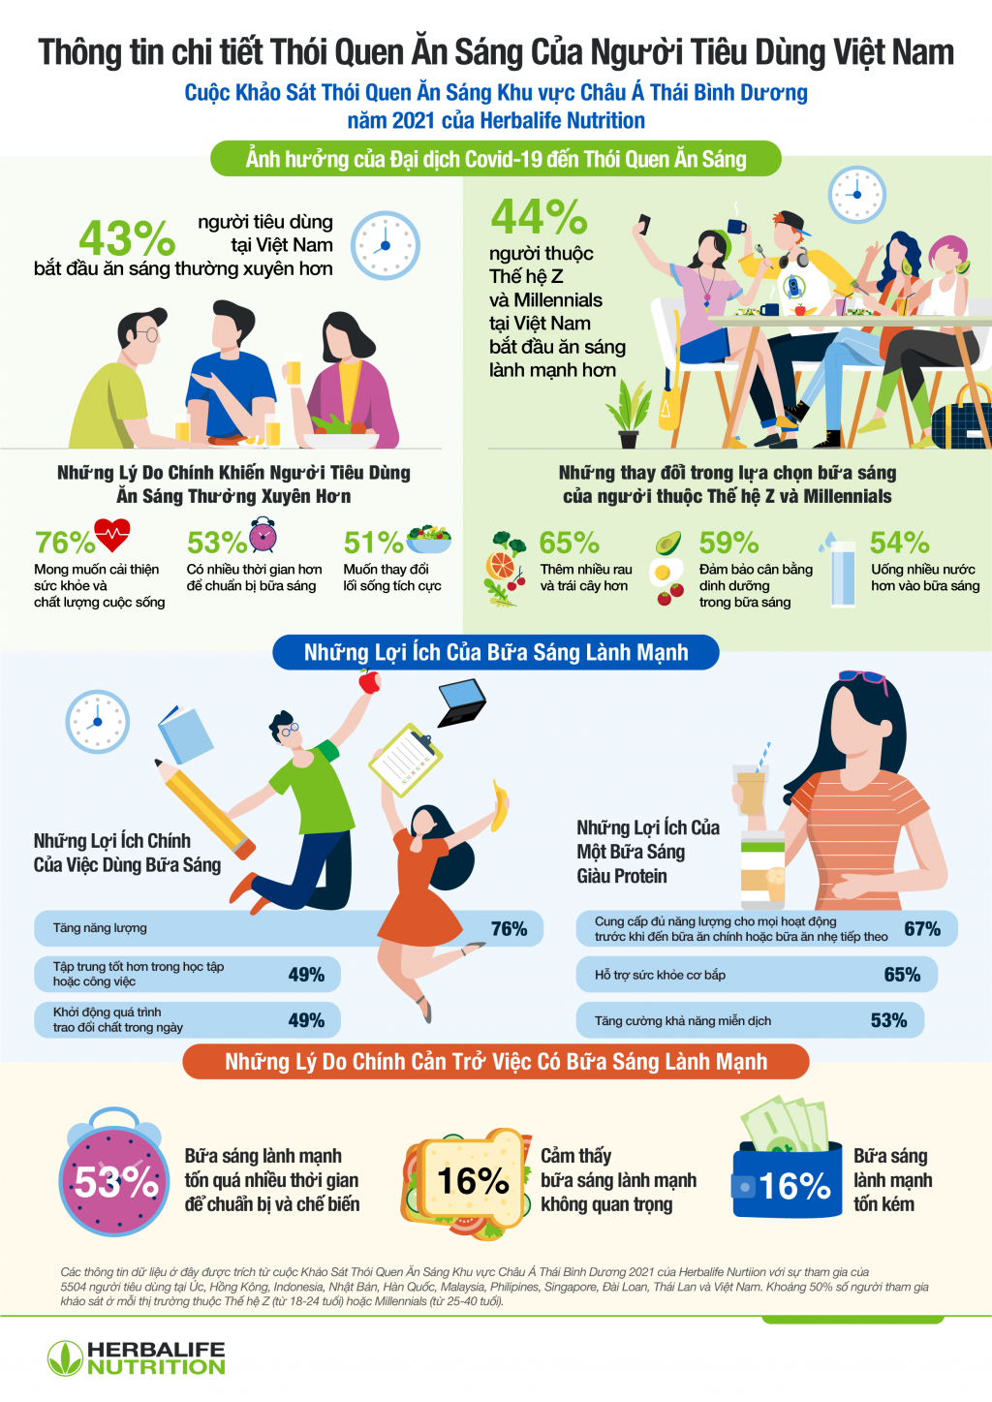

Survey respondents said that the main benefits included increased energy in the morning (90%), kick-starting their metabolism for the day (71%) and helping them concentrate better at school and work (70%).

According to iPOS.vn's 2023 Food Business Market Report, 20.4% of diners did not order online in 2023, an increase of 7.4% compared to 2022.

However, the frequency of online ordering among Vietnamese people remains high, with 29.4% ordering food delivery 1-2 times/week, and 20% ordering food delivery 3-4 times/week. Revenue from the online food delivery market in 2023 grew by more than 20.18%, reaching 52.4 trillion VND.

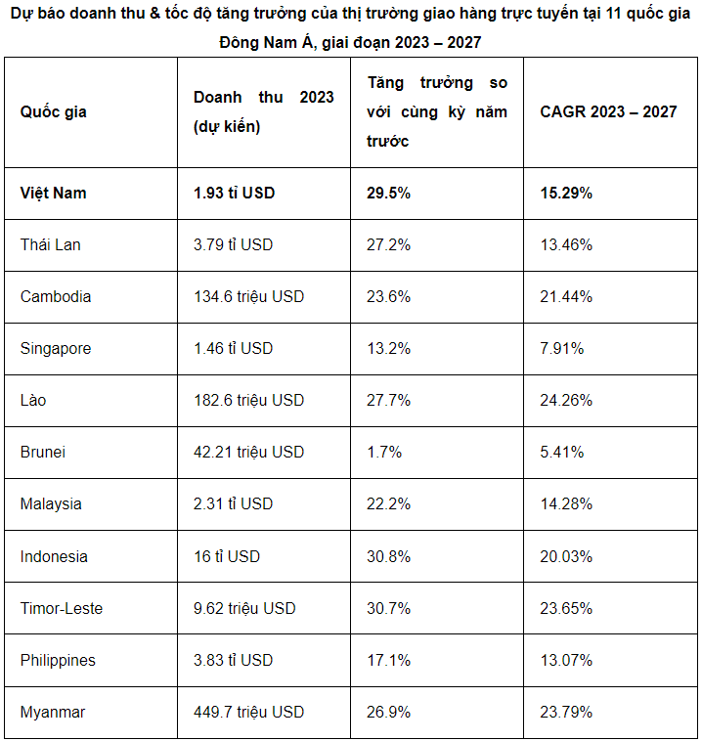

Vietnam's online food delivery market revenue is expected to reach US$1.93 billion in 2023, up 29.5% compared to 2022, and the CAGR for the 2023-2027 period is 15.29%, equivalent to US$3.41 billion in revenue in 2027.

### **2. SURVEY**

### **3. MARKET MIX**

#### **a. Product**

**Services provided:** Allows breakfast ordering with a variety of Menu options designed based on the user's personal taste preferences.

**Diverse and flexible menu:** With menus for a variety of customers such as vegetarians, gym goers, weight loss, healthy eating

**Personalization feature:** Allows users to customize and personalize the menu according to their preferences and diet.

**On-time delivery:** Ensure timely delivery of breakfast to users, meeting their need for convenience and speed.

#### **b. Price**

**Reasonable price:** Aiming for affordable price of about 20,000 - 50,000 VND, suitable for the majority of customers from low to high income.

**Discount** : 2-5% discount for new customers.

**Free Ship:** Get 1 free shipping voucher when ordering 10 orders.

#### **c. Place**

**Website platform:** initially provide a convenient, user-friendly website that allows users to easily book, schedule and track orders while accessing the website.

**Access area** : currently will approach the market of customers in Quy Nhon City and suburbs around the city.

**Building an internal delivery team** : When developing a separate delivery team, the group will ensure service quality and good control of delivery time.

#### **d. Promotion**

**1. Leverage the power of social media in Vietnam**

**In Vietnam** , social media platforms such as **Facebook, Instagram, Zalo, and TikTok** have extremely high usage rates, so the team will focus on these channels to reach consumers.

**Facebook & Instagram Ads:** Run geo-targeting ads to reach customers in the province. Ads can include images of traditional Vietnamese breakfast dishes (banh mi, pho, bun, xoi) and include a message about the convenience of ordering through the app.

**For example: "Waking up late? Order your favorite breakfast through our app and have it delivered to your door in minutes!"**

**Zalo Ads:** Zalo is a social network that is extremely popular among Vietnamese people. Therefore, if possible, you can take advantage of Zalo advertising to help reach domestic customers with banner ads or advertising messages to customers.

**TikTok Ads:** TikTok is currently the most popular trend in Vietnam, especially among young people. Use TikTok to create engaging short videos about the journey of ordering breakfast, from choosing the dish to receiving the goods. The video content will tend to be light, humorous and accessible to be able to attract young people.

**2. Localized promotions and offers**

To attract customers, promotional programs need to be designed to be attractive and suitable for Vietnamese spending habits.

**First-time discount offer:** Offer incentives to new users, such as free first-time shipping or 3-5% off their first order. This gives customers an incentive to try the service.

For example: "Order your first breakfast through our app, get 3-5% off and free delivery!"

**Loyalty points program:** Every time customers order, they accumulate points to redeem for future gifts or discounts. This helps increase the rate of returning customers.

### **4. COMPETITOR**

*For the competitive market providing home food delivery services, there are long-standing competitors in the market such as:* ***ShopeeFood, GrabFood, Gojek, Baemin*** *. This market is currently relatively competitive. But the two strong and famous competitors in the market are* ***ShopeeFood*** *and* ***GrabFood*** *.*

|  | **DawnFood** | **ShopeeFood** | **GrabFood** |
| --- | --- | --- | --- |
| **Custom menu according to food portion** |  |  |  |
| **Schedule food delivery for multiple days** |  |  |  |
| **Instant food delivery on orders** |  |  |  |
| **Suggested menu for many audiences (diet, gym)** |  |  |  |
| **Flexible payment support (E-wallet, card, COD)** |  |  |  |
| **Regular promotions** |  |  |  |

## 

## **III. Business Model Canvas and Technology Tool**

| [Business Model Canvas](https://miro.com/app/board/uXjVLNuJefg=/) |
| --- |

### **1. Business Model Canvas**

#### **a. Key partners**

*Supplier*

* Restaurants: Food delivery partners, especially breakfast and other menus, will be restaurants and food delivery units linked to the web platform and mobile app.

*Community or Local Sales Group*

* Local Sales Groups: These groups can help promote and distribute services to local areas, helping to grow your network of potential customers.
* Community groups: Act as a marketing and promotion channel by introducing products and services to members in the area, especially forums, Facebook groups, or culinary groups.

*Payment partner*

* Online payment gateways: Cooperate with reputable payment gateways such as PayPal, MoMo, ZaloPay, Visa, and banks (such as Vietcombank, Techcombank, ACB, MB bank,....) to provide convenient and safe payment options for customers.
* Bank partners: Vietcombank, Timo, Momo, MB bank,.. Help support payment transaction processing, provide preferential services or refunds when customers use payment methods of partner banks.

*Marketing partner*

* Advertising company: Cooperate with advertising companies to deploy marketing campaigns on Google, Facebook, Instagram,... to attract new users and retain existing customers.
* Influencers and food bloggers: Collaborate with social media influencers and food bloggers to promote the platform and dishes from partner restaurants.

*Transport*

* Internal delivery team: Build and manage your own delivery team to ensure fast, professional delivery and control of service quality.

#### **b. Key activities**

***Website & App* :** To enhance customer experience and process, the team will first build a website with a friendly interface and easy-to-use features. Then develop it into a mobile app (IOS, Android).

***Supplier Relationship Management*** : Work with suppliers to negotiate prices and cooperation as well as build a diverse breakfast menu. Ensure quality and delivery time from suppliers.

***Transport* :** The development team will build a main delivery team for the project without cooperating with any other parties in the delivery sector (such as shoppe food, grabfood, etc.). There will be a team in charge of the delivery process to users and handling feedback from users.

***Marketing and Promotion* :** Promote the website with food images, especially breakfast dishes and short videos introducing on many social networking platforms (Tiktok, Instagram, Facebook,...) or email or communities and Local Sales groups that have participated, related forums. Prioritize developing the model in Quy Nhon and then develop it nationwide. Create promotions for the first order on the web-app.

***Customer Support:*** Always respond promptly to potential buyers, providing additional details or clarifying any relevant information. Collect and analyze feedback from users.

#### **c. Value Proposition**

***For Users:***

* **Individual consumers**

Order food, especially breakfast food quickly. Through the application, it provides convenience and saves time, home delivery, suitable for busy lifestyles or lazy cooking.

Diverse menu, updated regularly and can be pre-ordered 2-7 days in advance according to demand.

Offer promotional offers, promotions for the first booking when booking via web - app

* **Small Business**

Convenient food delivery solutions save time organizing meals for employees.

Customize to fit your business needs.

Support internal business events when needed.

* **Event organizing groups**

Full service food and beverage delivery to event venue.

Convenient and fast: Caters to small and medium sized events.

***With Supplier* :**

Increased reach: Your customer base will expand and your revenue will increase.

Reduce marketing costs: Focus more on menu quality => Encourage suppliers to launch new dishes.

#### **d. Customer Relationship**

* *For Users:*
* **Individual consumers**
  + Customer Support: Phone, email or live chat support to quickly resolve breakfast questions and issues.
  + Offer Notifications: Send out notifications of offers, promotions, new breakfast items and useful news to keep customers engaged.
  + Loyalty customers: Regularly create promotions for frequent customers.
* **Small Business**
  + Partnerships: Need to establish close relationships with small businesses, providing customized services according to their needs.
  + Support for internal events: Ensure food and delivery times for smooth internal events.
  + Notifications & communications: Send information about special business packages and related promotional offers.
* **Event organizing groups**
* Personalized Support: Consulting services help groups choose the menu for their event.
* Offer: Offer special offers for large orders, helping to save more costs.
* Survey & Feedback: Conduct post-event surveys to gather feedback => Improve service and menu for next time.
* *With Supplier:*
  + Cooperation: Establish sustainable relationships with suppliers.
  + Communication: Stay connected to stay updated on user needs and new products and promotional offers.
  + Feedback and improvement: Surveys collect feedback from suppliers to improve performance, processes and quality.
  + Promotion: Provide special promotional incentives when suppliers participate in the platform's marketing campaigns.

#### **e. Customer Segments**

**Location** : Users are mainly those who need to use the service of the food ordering project, especially breakfast in Quy Nhon - Binh Dinh - Central region in particular and the whole country in general.

**Target audience:** People mainly between 18 - 40 years old can be classified as follows:

*Main segment* : Individual consumers, mainly young people such as students and busy adults, who often go to work and skip breakfast, have little time to prepare breakfast. Like convenience and often use mobile phones.

*Expanded segment* : Small businesses - need to provide food for employees or organize events at the company with the need to order food for meetings, seminars, or internal events.

*Expanded segment* : Event organizing groups (10 people or more) - Organizations, clubs, or groups that need to order food for events such as birthday parties, seminars, workshops, or small to medium-sized community events.

#### **f. Key resources**

***Human Resources***

* Development Team: Team that develops and maintains websites and apps (iOS, Android), ensuring stable features and operating systems. Can develop new features.
* Marketing Team: Promote services, carry out advertising campaigns on social networking platforms and other media.
* Customer Support Team: Handle and communicate with customers quickly. Help answer and support as well as collect feedback to improve the platform and service.
* Supplier Management Team: Manage and contact suppliers, ensure quality, price and time for delivery process.

***Technology resources***

* Website and App Infrastructure: Servers, infrastructure, and software tools required to build, manage, and maintain web platforms and mobile applications.
* Payment Gateway Integration: Secure payment system, integrating many popular payment methods (credit cards, e-wallets, bank transfers).

***Finance resources***

* Capital: Initial investment and cash flow to sustain business operations, pay for technology development costs, employee salaries, and day-to-day operating expenses.
* Contingency Fund: A reserve fund to deal with emergencies, future expansion or improvement of services.

***Partnerships***

* Payment Partners: Ensure partnerships with payment gateways and banks to process payments securely and conveniently for users.
* Food suppliers: Restaurants and eateries provide quality dishes and regularly update their menus, ensuring menu diversity.

#### **g. Channels**

* *Online channel*
* Website and App: Main channels for users to order food, especially breakfast food.
* Social Media: Use platforms like Tiktok, Facebook, Instagram to promote food especially breakfast food and promotional offers. Create good content to encourage users to share their experiences.
* Email Marketing: Send periodic promotional offers and useful information to registered and unregistered customers to stay in touch and expand your customer base.
* *Media channels*
* Partner with food bloggers and influencers for promotion.
* The team runs Ads and creates campaigns based on consumer behavior and interests.
* Events and workshops: Participate to promote the platform and services.
* *Partner Channel*
* Suppliers who participate in the platform can recommend the platform to their other customers, creating trusting partnerships and increasing sales and user base.

#### **h. Cost structure**

* Fixed costs:
* *Website and mobile app development* : Design, build, and maintain website and app systems that display restaurant menu lists.
* *Employee Salary* : Salary for staff (programmers, customer service staff, operations team managers and delivery team).
* *Technology infrastructure costs* : Server hosting, database management and security costs for websites and online transactions.
* Costs related to supplier:
* *Supplier Commission* : Fee paid to partner restaurants based on order revenue
* *Menu Development Costs* : Invest in developing new dishes with the restaurant.
* Variable costs:
* *Delivery team operating costs* : Salaries for delivery staff, other costs related to the delivery process.
* *Marketing and advertising fees* : The cost of online advertising on Google, Facebook, Instagram, and other platforms to attract new users.
* *Payment processing fee* : Fee paid to online payment gateways when users pay via credit card or e-wallet.
* *Restaurant Partner Fees* : Costs associated with managing and maintaining relationships with partner restaurants.
* Other operating costs:
* *Customer service* : Cost of maintaining customer support (personnel and automated or phone/email answering systems).
* *Software costs* : Includes the cost of using order management, distribution, and marketing tools.
* *Promotional costs* : Incentives, discounts and promotions for new users and regular customers.

#### **i. Revenue stream**

* *Commission from orders* : Commission from restaurants: Receive a percentage of commission from each successful order from partner restaurants. The commission percentage will be based on the value of the order.
* *Shipping fee:*
* Customer Delivery Fee: Charge customers a delivery fee for each order. This fee can be flexible based on distance, order volume, or delivery time.
* Premium Delivery Fees: Charge more for express or special request delivery services (short-term delivery, time-sensitive delivery).
* Services for partner restaurants:
* Platform Advertising Fees: Provide advertising packages or prominent display for restaurants on the website to increase customer reach.
* Data Analytics Fee: Provides user behavior data and detailed order reports to restaurants for a fee.
* User subscription package:
* Long-term meal booking package: Provide pre-booking service for weekly or monthly meals at preferential prices, ensuring stability for both users and partner restaurants.
* Special order processing fee:
* Order Cancellation or Change Fee: Charged when a user cancels or changes an order that has been prepared or delivered in a short time.

### **2. Technology Tools**

* Static web: ReactJS
* Web-service: NodeJS
* API: ChatGPT
* IDE: Visual Studio Code
* Deployment: Render
* Database: MongoDB

## **IV. Operation**

### **1. Supplier Relationship Management**

#### **1.1. Identify and select suppliers**

Identify suppliers who can provide a variety of dishes, over a long period of time, and consistently. Prepare on-site or transport by specialized vehicles.

Ensure high quality, suitable for each region's taste. Service range nationwide.

* Anh Hong Industrial Catering Company Limited
* Royal Industrial Catering Company Limited
* Tan Vuong Industrial Catering Company Limited
* Atesco Industrial Catering Company Limited
* United Food Joint Stock Company (Unifood)
* QFoody

Make sure that the supplier has achieved food safety certifications as required by state regulations such as **HACCP** , **ISO 22000** , or **GMP** .

Conduct unannounced inspections of supplier kitchens to ensure compliance with food safety and sanitation standards. Request inspections of sanitation systems, raw material storage, and processing procedures.

#### **1.2. Supplier reviews**

Before signing a long-term contract, conduct trial deliveries. Order a small amount of test meals from the supplier for a short period of time to evaluate the food quality, professionalism, and timeliness of delivery.

Based on feedback from customers (factories, enterprises, schools), it is possible to determine whether the supplier meets expectations.

#### **1.3 Negotiation**

**Price agreement:**   
The current breakfast set ranges from 15,000 - 30,000 VND, depending on the dish.   
**High-priced group:** Beef noodle soup, Hue beef noodle soup, Quang noodles with shrimp and pork, Crab noodle soup, Nam Vang noodles, Pork leg noodle soup.

**Mid-priced group:** Meatloaf, Savory sticky rice, Meat rolls, Chicken porridge, Vegetarian Quang noodles, Vegetarian vermicelli soup, Vegetarian Hu Tieu.

**Low price group:** Vegetarian pho, Vegetarian bread, Vegetarian sticky rice, Vegetarian rice rolls, Vegetarian mushroom porridge, Vegetarian bamboo shoot vermicelli.

**High price group:** Negotiate a higher price due to more expensive ingredients (like beef, pork leg, shrimp) price from **25,000 - 30,000 VND** for these dishes.

**Mid-range price group:** Negotiate a softer price, around **15,000 - 20,000 VND** , with common ingredients such as chicken and pork.

**Low Price Group:** Negotiate a fixed lower price of **VND 12,000** for vegetarian dishes or dishes with simple ingredients.

**5-10%** discount on total bill price.

**Contract Agreement:**

It is possible to start with a short term contract (3-6 months) to test the quality of service, then renew if everything goes well.

**6 month** contract : Ask for **3-5% discount** from listed price.

**1 year** contract : Request **5-10%** discount on total order value.

Establish **key performance indicators (KPIs)** such as on-time delivery, product quality, and cost control.

Often search for new suppliers to replace several products as a way of stamping out competition.

### **2. Customer Relationship Management**

#### **2.1. Manage all customer data**

**Storage information**

**Personal:** Name, address, phone number, favorite dishes, order history, service feedback.

**Business:** Contact information of representative, specific requirements for meals (quantity, dishes), delivery time.

#### **2.2. Building a customer care program**

**Regular promotions:**

* Holiday discount code program.
* Discount code program for first order
* Create a **"Buy 5 Get 1 Free" program** for individual customers. After purchasing 5 meals, customers will receive one free meal.

**Loyalty customer care:** For individual customers who regularly order through the system, set up a **points accumulation program** . For every 1,000 VND, customers receive 1 point. After accumulating 500 points, they can exchange for a free dish.

**24/7 Support Service:** When customers have problems with their orders, such as slow delivery, they can contact us via **hotline** or **online chat** to receive immediate support.

#### **2.3. Feedback analysis and service optimization**

After each order, send a survey via email or app for customers to evaluate service quality:

**Quick survey:** Ask customers about the food they ordered, delivery time and delivery staff attitude.

**Improve service:** Based on feedback on savory dishes, you adjust the seasoning to better suit customer tastes, and monitor the positive feedback rate after this change.

#### **2.4. Personalize the customer experience**

**Food recommendations:** Based on purchase history, the CRM system can send automatic notifications suggesting new dishes to customers.

**Personalized menu**

* Allow customers to create their own menu for 3-7 consecutive days.
* Allow customers to create their own menu and schedule for the next 7 days.

#### **2.5. Evaluation of performance indicators**

**Customer return rate:** Individual customers who return to use the service after participating in the loyalty program.

**Satisfaction rate:** Through the survey, customers rated the food as meeting the requirements in terms of quality and delivery time.

**Loyalty Revenue:** How much of your total monthly revenue is generated from returning customers who have earned points.

**Promotion conversion rate:** Customers used discount codes from promotions and re-ordered new recommended dishes.

### **3. Employee Relationship Management**

#### **3.1. Compensation and benefits policy**

**Performance bonus:** 10% of basic salary if KPIs are achieved.

**Social benefits:** Health insurance, social insurance, unemployment insurance (deducted according to state regulations: 32% of basic salary).

**Innovation bonus:** VND 5,000,000 for innovative ideas that increase productivity or reduce production costs by over 10%.

#### **3.2. Training and development**

**Training costs:** The company invests **2,000,000 VND/person/year** in professional and soft skills training courses.

#### **3.3. Reward and recognition policy**

**Productivity Bonus:** If employees achieve **120% of KPIs** in 6 months, they receive a bonus equivalent to **20% of their basic salary** .

**Outstanding employee reward:** **3,000,000 VND** /quarter for best employee.

**Internal Email Recognition:** At least **10% of employees** each month are recognized and rewarded in the internal newsletter.

#### **3.4. Employee retention policy**

**Retention bonus:** After 2 years of work, each employee will receive a bonus of **1 month of basic salary** , equivalent to.

**Annual salary increase cost:** The company applies an **8% salary increase** per year for long-term employees.

#### **3.5. Performance evaluation**

**Attrition rate:** After 1 year of implementation.

**Employee satisfaction rate:** After implementing welfare policies and training programs.

**Long-term employee turnover:** After employees participate in training and development programs.

**Percentage of employees working over 2 years:** After 2 years of implementing employee retention policy.

### **4. Inventory management**

* Ensure adequate supply of meals to customers on time.
* Management of goods related to packaging and transportation (such as packaging, preservation materials, specialized vehicles).
* Track and manage orders from suppliers and deliveries to customers.
* Optimize storage and movement of goods to ensure uninterrupted service.

## **V. Financial Analysis (projection for 5 years)**

### **1. Initial costs: (Year 0)**

These are the initial costs that include the amount required to start the business and the one-time payments to set up and implement the business system. These costs are forecasted as follows:

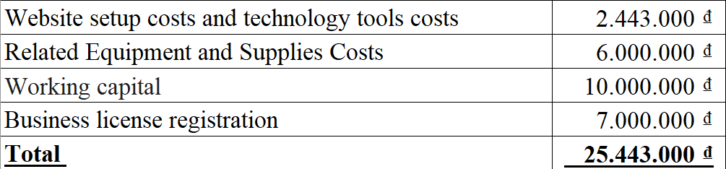

* Website setup costs and technology tools: Dawn Food operates mainly on an online sales model, so we will invest optimally in website costs including domain name purchase costs (1,983,000 VND) and tools for the websites (460,000 VND). Total is 2,443,000 VND
* Business registration fee: using business registration services from consulting companies will be supported with prices and related procedures, this fee is 7,000,000 VND
* Working Capital: To ensure we have enough resources to deal with unexpected situations, we reserve VND 10,000,000 for other incidental expenses.

### **2. Revenue stream: (Year 1,2,3,4,5)**

Assuming DawnFood sells an average of 1,500 products per month, we will recalculate monthly, annual and cumulative revenue for each year. Keep the price per product at 25,000 VND and the annual growth rate at 10%.

* **Initial monthly revenue** : 800 products * 25,000 VND = 20,000,000 VND
* **Annual growth rate** : 10%

**Year 1:**

* **Initial monthly revenue** : 800 products * 25,000 VND = 20,000,000 VND
* Monthly revenue: 20,000,000 VND
* Annual revenue: 20,000,000 VND * 12 = 240,000,000 VND
* Accumulated revenue: 240,000,000 VND

**Year 2:**

* **Initial monthly revenue** : 865 products * 25,000 VND = 21,625,000 VND
* Monthly revenue: 21,625,000 VND * (1+10%)= 23,787,500 VND
* Annual revenue: 23,787,500 VND * 12 = 285,450,000 VND
* Accumulated revenue: 240,000,000 + 285,450,000 = 525,450,000 VND

**Year 3:**

* **Initial monthly revenue** : 1,215 products * 25,000 VND = 30,375,000 VND
* Monthly revenue: 30,375,000 VND * (1+10%) = 33,412,500 VND
* Annual revenue: 33,412,500 VND * 12 = 400,950,000 VND
* Accumulated revenue: 400,950,000 VND + 525,450,000 VND = 926,400,000 VND

**Year 4:**

* **Initial monthly revenue** : 1,345 products * 25,000 VND = 33,625,000 VND
* Monthly revenue: 33,625,000 VND * (1 + 10%) = 36,987,500 VND
* Annual revenue: 36,987,500 VND* 12 = 443,850,000 VND
* Accumulated revenue: 443,850,000 VND +926,400,000 VND = 1,370,250,000 VND

**Year 5:**

* **Initial monthly revenue** : 1,554 products * 25,000 VND = 38,850,000 VND
* Monthly revenue: 38,850,000 VND * (1 + 10%) = 42,735,000 VND
* Annual revenue: 42,735,000 VND * 12 = 512,820,000 VND
* Accumulated revenue: 512,820,000 VND + 1,370,250,000 VND = 1,883,070,000 VND
* **Accumulated revenue after 5 years** : 1,883,070,000 VND

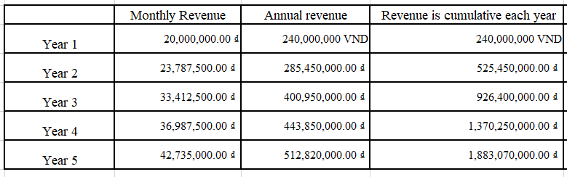

### **3. Operating expenses: (Year 1,2,3,4,5)**

These are the regular expenses that are used to maintain the business operations. These expenses can always be

same (fixed) or change based on business activity (variable).

#### **a. Fixed costs:**

DawnFood's fixed costs over 1 to 5 years will include recurring expenses that do not vary much with revenue. These costs include:

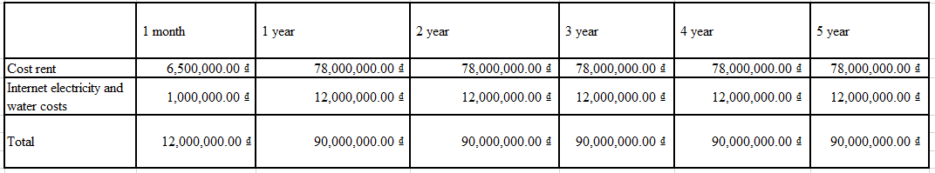

#### **b. Variable costs:**

DawnFood's variable costs vary based on the store's production or sales levels. When running a business, variable costs may include:

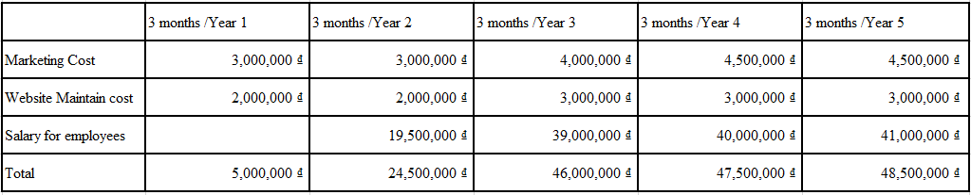

#### **c. Total cost:**

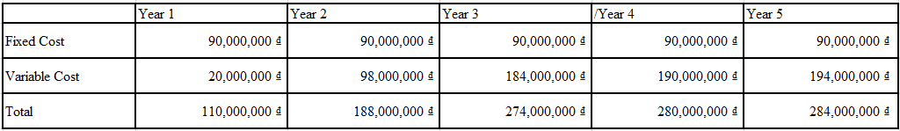

### **4. Expected Profits:**

